Figure 1

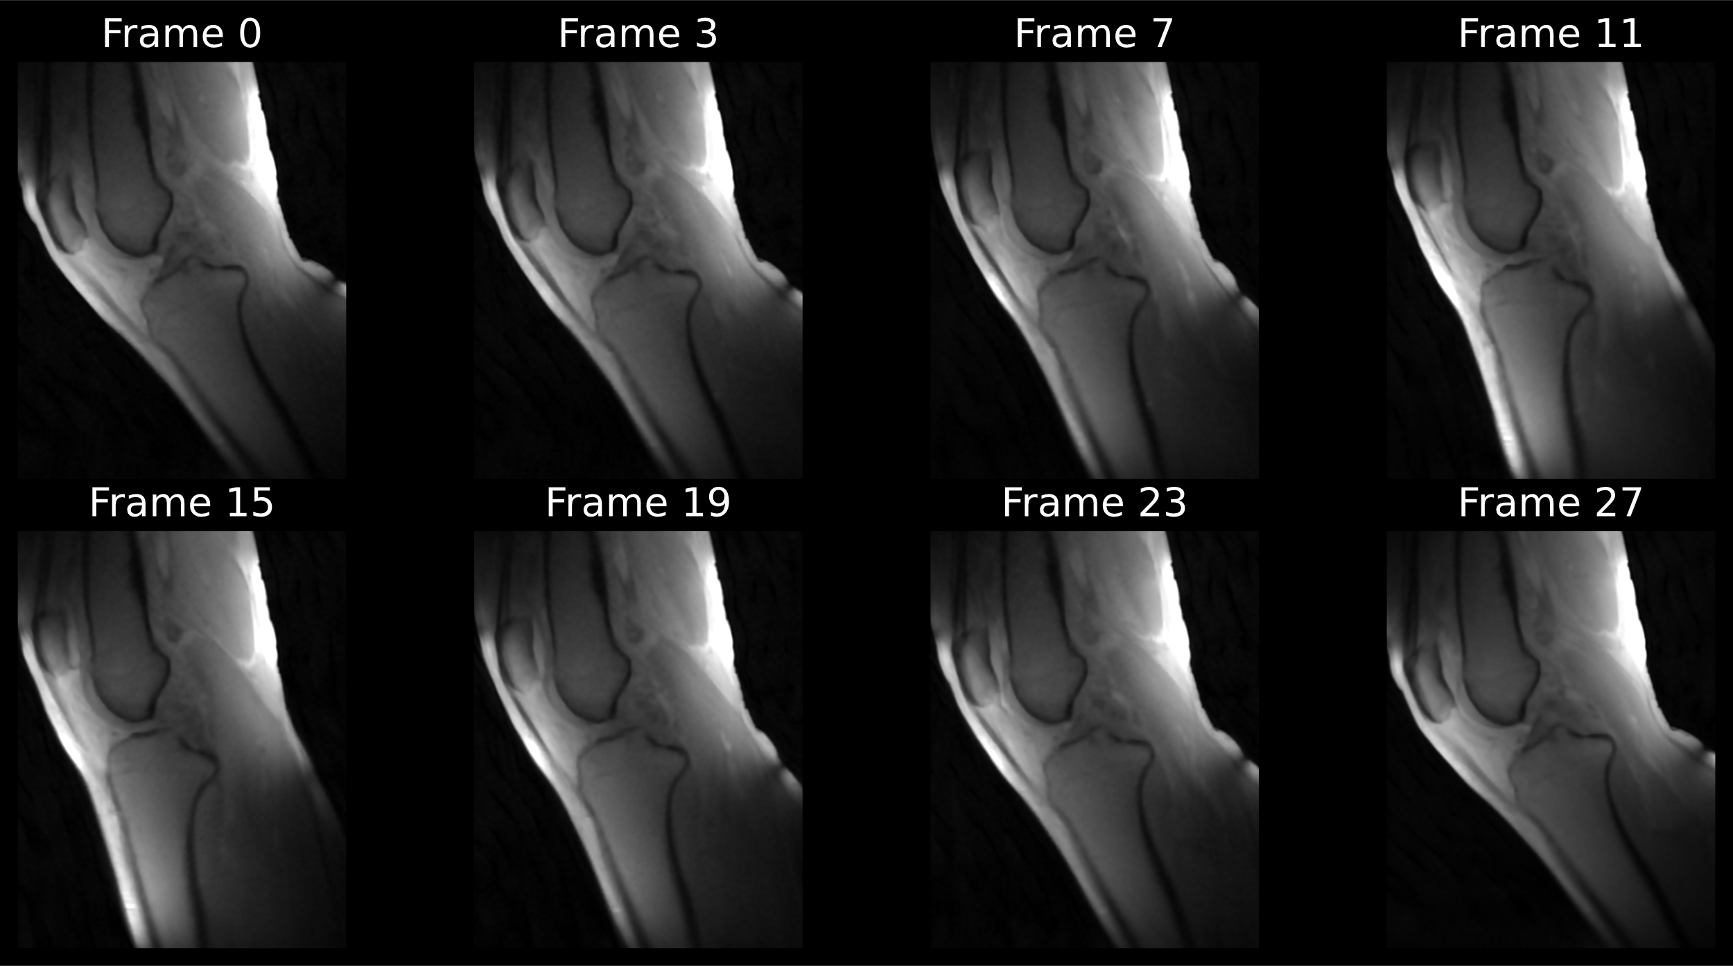

Figure 2

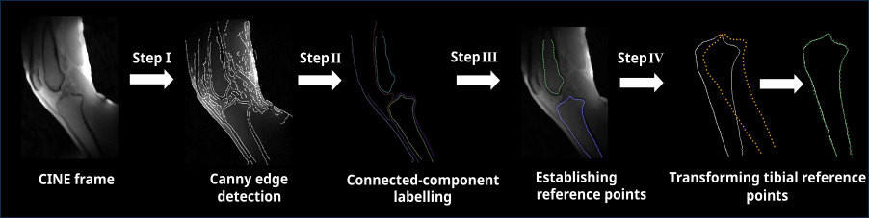

Figure 3

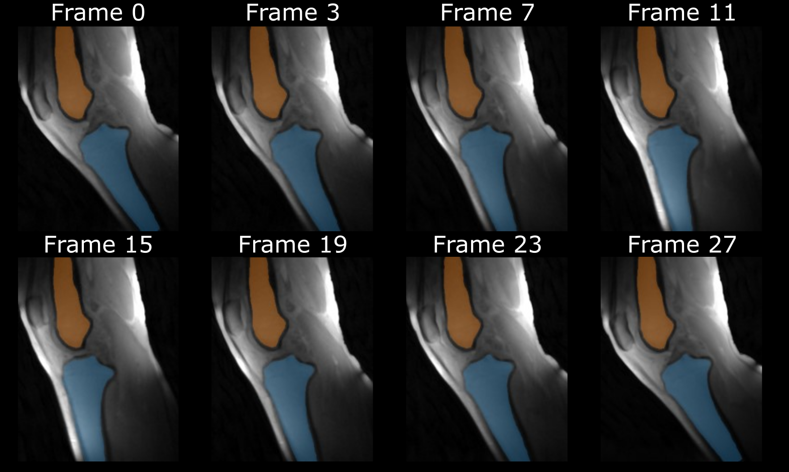

Figure 4

Figure 4 (alternative)

